Hadoop Cheatsheet

Table of Contents

Copy a file from the Hadoop HDFS directory to your local directory 3

List the contents of the root directory in HDFS 3

Navigate to another user’s Directory

%sx hadoop fs -ls /user/trasamsetti/Deshipmentdata

# Open a terminal window to the current working directory.

# /home/training

# 1. Print the Hadoop version

hadoop version

# 3. Report the amount of space used and

# available on currently mounted filesystem

#

hadoop fs -df hdfs:/

# 4. Count the number of directories,files and bytes under

# the paths that match the specified file pattern

#

hadoop fs -count hdfs:/

# 5. Run a DFS filesystem checking utility

#

hadoop fsck – /

# 6. Run a cluster balancing utility

#

hadoop balancer

# 7. Create a new directory named “hadoop” below the

# /user/training directory in HDFS. Since you’re

# currently logged in with the “training” user ID,

# /user/training is your home directory in HDFS.

#

hadoop fs -mkdir /user/training/hadoop

# 8. Add a sample text file from the local directory

# named “data” to the new directory you created in HDFS

# during the previous step.

#

hadoop fs -put data/sample.txt /user/training/hadoop

# 9. List the contents of this new directory in HDFS.

#

hadoop fs -ls /user/training/hadoop

# 10. Add the entire local directory called “retail” to the

# /user/training directory in HDFS.

#

hadoop fs -put data/retail /user/training/hadoop

# 11. Since /user/training is your home directory in HDFS,

# any command that does not have an absolute path is

# interpreted as relative to that directory. The next

# command will therefore list your home directory, and

# should show the items you’ve just added there.

#

hadoop fs -ls

# 12. See how much space this directory occupies in HDFS.

#

hadoop fs -du -s -h hadoop/retail

# 13. Delete a file ‘customers’ from the “retail” directory.

#

hadoop fs -rm hadoop/retail/customers

# 14. Ensure this file is no longer in HDFS.

#

hadoop fs -ls hadoop/retail/customers

# 15. Delete all files from the “retail” directory using a wildcard.

#

hadoop fs -rm hadoop/retail/*

# 16. To empty the trash

#

hadoop fs -expunge

# 17. Finally, remove the entire retail directory and all

# of its contents in HDFS.

#

hadoop fs -rm -r hadoop/retail

# 18. List the hadoop directory again

#

hadoop fs -ls hadoop

# 19. Add the purchases.txt file from the local directory

# named “/home/training/” to the hadoop directory you created in HDFS

#

hadoop fs -copyFromLocal /home/training/purchases.txt hadoop/

# 20. To view the contents of your text file purchases.txt

# which is present in your hadoop directory.

#

hadoop fs -cat hadoop/purchases.txt

# Copy a file from the Hadoop HDFS directory to your local directory

Add the purchases.txt file from “hadoop” directory which is present in HDFS directory to the directory “data” which is present in your local directory

hadoop fs -copyToLocal hadoop/purchases.txt /home/training/data

Another example, from Jupyter Hub jupyter notebook:

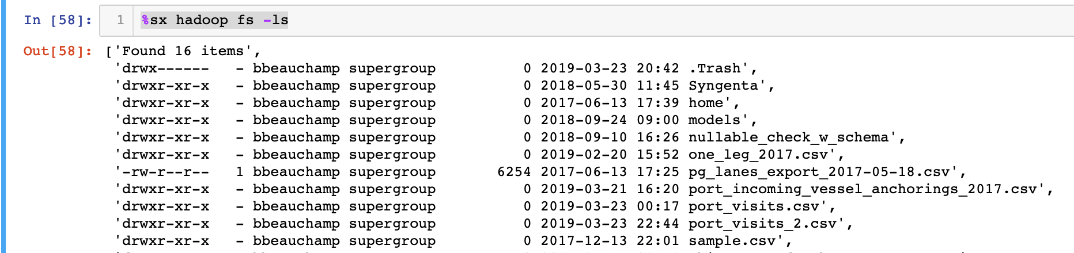

Causes a new folder to be created:

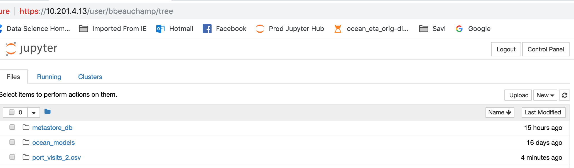

# List the contents of the root directory in HDFS

hadoop fs -ls /

# 22. cp is used to copy files between directories present in HDFS

#

hadoop fs -cp /user/training/*.txt /user/training/hadoop

# 23. ‘-get’ command can be used alternaively to ‘-copyToLocal’ command

#

hadoop fs -get hadoop/sample.txt /home/training/

# 24. Display last kilobyte of the file “purchases.txt” to stdout.

#

hadoop fs -tail hadoop/purchases.txt

# 25. Default file permissions are 666 in HDFS

# Use ‘-chmod’ command to change permissions of a file

#

hadoop fs -ls hadoop/purchases.txt

sudo -u hdfs hadoop fs -chmod 600 hadoop/purchases.txt

# 26. Default names of owner and group are training,training

# Use ‘-chown’ to change owner name and group name simultaneously

#

hadoop fs -ls hadoop/purchases.txt

sudo -u hdfs hadoop fs -chown root:root hadoop/purchases.txt

# 27. Default name of group is training

# Use ‘-chgrp’ command to change group name

#

hadoop fs -ls hadoop/purchases.txt

sudo -u hdfs hadoop fs -chgrp training hadoop/purchases.txt

# 28. Move a directory from one location to other

#

hadoop fs -mv hadoop apache_hadoop

# 29. Default replication factor to a file is 3.

# Use ‘-setrep’ command to change replication factor of a file

#

hadoop fs -setrep -w 2 apache_hadoop/sample.txt

# 30. Copy a directory from one node in the cluster to another

# Use ‘-distcp’ command to copy,

# -overwrite option to overwrite in an existing files

# -update command to synchronize both directories

#

hadoop fs -distcp hdfs://namenodeA/apache_hadoop hdfs://namenodeB/hadoop

# 31. Command to make the name node leave safe mode

#

hadoop fs -expunge

sudo -u hdfs hdfs dfsadmin -safemode leave

# 32. List all the hadoop file system shell commands

#

hadoop fs

# 33. Last but not least, always ask for help!

#

hadoop fs -help